Monocal – quick recs and how to buy it – Mericon Amazon – vs Rx preferred – supp schedule

The best way to get prenatal fluoride (PNF) is to ask your OB or dentist and get a prescription. This will usually be for small cheap sodium fluoride tablets, the same ones used for children over about 6 years old.

Here is the normal schedule. (Honolulu water is close to zero F, so first column, unless you live on a military base.)
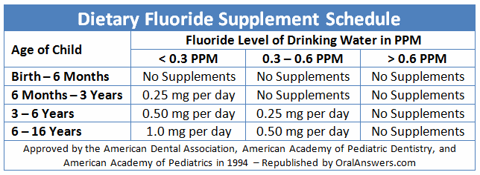
Ideally you and your doctor can just keep things simple. If you just say that you have heard that fluoride works better if started early, and that you would like to start as soon as your child's teeth start forming, maybe that will be all you need to do. But let's go a little deeper.

Note that what you are asking for is already off the chart (there are no supplements approved by the ADA below age 6 months). There are no commercial products that say “prenatal fluoride”. (Groan – this is illegal – here is one of my whackadoodle sites: https://sites.google.com/site/franceskelseyprenatalfluoride/home/why-prenatal-vitamins-do-not-have-fluoride-1 )

My recommendations for fluoride are for all of us to take a wee bit for all of our lives. The most important time is pregnancy. For normal adults, something like 1 mg F per day, especially for women who might conceive. If starting during early pregnancy (the first 2 months), half of the normal adult dose, so .5 mg F, just to not make any sudden changes during this most sensitive time. Once teeth start forming (3rd month), 1 mg F. Then at birth dose by body weight .033 mg F/kg. After 6 months go along with the pedi schedule above. (I will be glad to answer questions, send details, copies of trials, talk to your doctor, etc. The 1984 “pits” paper shows the clearest “developmental” effect.)

If you can't get a prescription from your doctor or dentist, and you want to take fluoride on your own, here is how to do it. You can order a product (Monocal, about $19) from Amazon. It has about 3 mg F in combination with a lot of calcium, which will tend to lower the effective dose (but who knows exactly by how much). So take one pill every 2nd or 3rd day, or nibble on the tablets (a little chalky but OK).
https://www.amazon.com/Fluoride-Monofluorophosphate-Calcium-Monocal/dp/B000M49Z5A?ie=UTF8&*Version*=1&*entries*=0

