Straighter teeth

Ray Grogan

One of the most overlooked nutrients of early pregnancy is fluoride. I am going to suggest that if a young woman takes the dosage recommended for the usual reasons (her own teeth and bones), she may also help her child-to-be have straighter teeth. The "proof" that fluoride in early pregnancy can help create straighter teeth is a little indirect, but let's take a look at what is there. It will boil down to just 3 things:

1. The closest thing to clinical proof is that it looks like having higher fluoride in the water reduces crooked teeth.

2. The timing makes fair sense in that the jaw shape and the placement of teeth seems to happen in the first few months of pregnancy.

3. The natural diet of hunters and gatherers had lots of fluoride and they pretty much all had perfectly straight teeth. (On this one I tend to go on and on. To me this was a good way to see if fluoride was a natural thing or some weird chemical.)

There is some evidence that fluoride (in general) may help prevent crooked teeth (malocclusion). (Moller IJ, 1965. Dental Fluorose Og Caries. Rhodos. (Danish with English summary and tables.) Moller's review of 5 studies concludes that, "Most authors seem to agree that the prevalence of malocclusion is less in fluoride areas than in low-fluoride areas". His own study from 4 areas in Denmark found that the higher the fluoride in the water, the more children had straight teeth (chart below shows the % of 12 year olds with normal tooth position went up from 56.1% when the water had .05 ppm F up to 74.15% when the water had 1.9 ppm F, P<.05). A few years later another review was more neutral: WHO, 1970. Fluorides and Human Health. Page 351.)

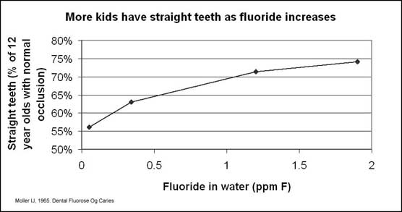

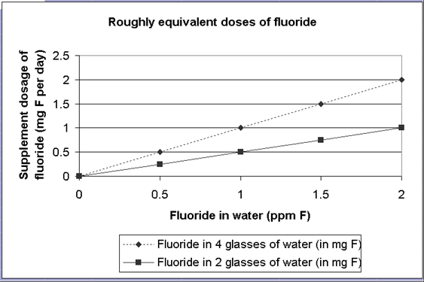

The first chart clearly suggests that more kids get straighter teeth growing up in higher fluoride areas. The second chart just shows how much fluoride a person would get by drinking the water. We just don't know much more than that about dosage. The point is that a normal dose for a young woman (1 mg F) is in the ballpark.

For the moment, let's assume that a reasonable dose of fluoride causes straighter teeth. Next is the tricky question of WHEN does fluoride have the presumed effect.

The reason I think this effect is from early pregnancy is biological. The shape of the jaw, which most logically makes the most difference between straight and crooked teeth, is set very early in pregnancy and has almost nothing to do with heredity. (The spacing of teeth can be seen by the 11th week of pregnancy. Garn 1979, Journal of Dental Research 58(2):554.) Whenever the spacing is set, it is before prenatal fluoride is started (about the third month, when teeth start forming). Prenatal fluoride does not do anything (or at least not much) to prevent crooked teeth. Here is a little tale about that.

When I started doing some fairly serious reading about prenatal fluoride, I ran into something that was a little spooky. A report* by Dr. Glenn made me wonder if prenatal fluoride somehow caused kids to need braces.

The main point of this report is that dentists can get more business from less cavities. Dr. Glenn found that her prenatal fluoride patients (the ones with no cavities at all) actually gave her more business. The cavity-free children spent $338 per year per person, versus $234 per year for the children with cavities. It is interesting that Dr. Glenn found this spending difference even in the same family, where one child would have cavities and the other would not.

There is no further spending breakdown, but it is implied that the parents are so impressed with the beautiful and cavity-free teeth that they are far more willing to spend big bucks on orthodontics. (I do not have an exact figure, but local dentists tell me a set of braces costs about $2,000. This cost is generally not insured.)

You can find a small confirmation that parents put more braces on cavity-free kids in a trial of infant fluoride by Aasenden**. In the second [1978] trial, when the children are about 15 years old, the subject of braces comes up. There were so many more cases of braces in the fluoride group than in the controls that the authors were concerned about whether the control group was actually a good comparison.

When I started wondering about the possibility that fluoride caused the need for braces, I wrote to Dr. Glenn. He [Darby] assured me that it really was a simple matter of the parents' willingness to pay for the treatment. Prenatal fluoride made absolutely no difference in the need for braces. Both groups -cavities or not - needed them equally. Prenatal fluoride creates beautiful individual teeth, but it does nothing for the way those teeth are arranged in the mouth.

Here are some drawings of teeth in jaws very early in pregnancy - about half are straight, the rest are already crooked.

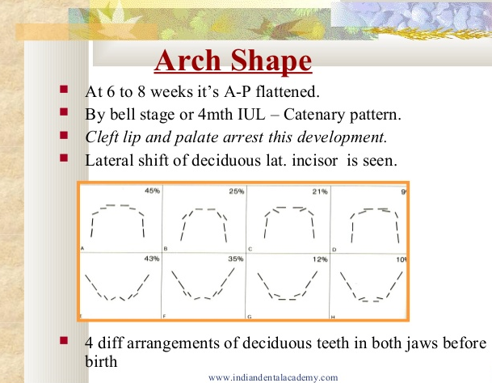

I am hoping we can develop ways to see the arch shape just by taking a picture of a newborn’s roof of mouth and gum line. This one was described as a high palate. (Walmart online has an “intraoral” camera for just $23 that might be handy.)

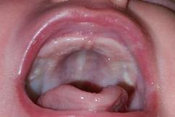

Here are adult palates:

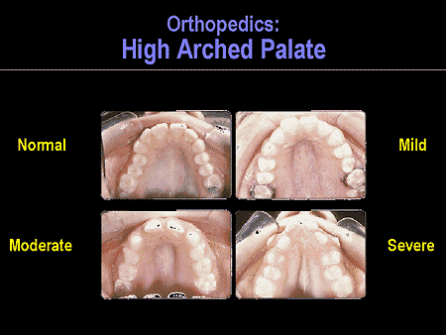

Now let's stray deep into ancient history. This is a pretty obscure area of fluoride research, but I love it. In a nutshell, our ancestors, the earliest hunters and gatherers, had fluoride intakes vastly greater than we do today. And they had, among other things, very straight teeth. It will take me a while to put it all together.

Fluoride is usually in the rougher-tougher parts of foods. For an extreme example, the whole grain that cows eat has about 100 times the fluoride of the bread that we eat***. The same is true between their pasture grass and our vegetables like broccoli. Many foods are of course the same (an apple is an apple, gathered or bought). In total, a reasonable estimate is that hunters and gatherers got about 5 times the fluoride of modern people.

I always think of hunters and gatherers as eating more small whole animals (complete with bones, shells, scales, teeth, etc.) or big animals with their bone marrow. And lots more greens, which are the easiest and most consistent food you can find. These foods aren't super-rich in fluoride, but typical of the food chain. In modern foods many of the replacements are low and approaching zero: muscle meat, iceberg lettuce, sugar, etc.

Some early peoples got more fluoride than others. There was at least one group of hunters and gatherers who got enough fluoride to cause fluorosis. This was in the South Pacific, in the Austral Islands. "The inhabitants of the Australes and Savaii continue to eat traditional Polynesian food. From this, particularly fish, taro root, and coconut, they absorb sufficient dietary fluorides to produce slight mottling of their permanent teeth. A recent survey (1970) of the school age population of the Australes showed an incidence of 90% of mild white flecked fluorosis and of 6% moderate brown flecked fluorosis." The author was also comparing the teeth of the natural-living islanders to the teeth of Tahitians who had a more modern diet. The saddest of the modern cases was a bevy of otherwise beautiful teenaged girls who had no teeth left at all.

(The source is Baume, 1970. Arch Oral Biol 15:431; and Indent 1(3):36. The water fluoride level in the Australes was .5 ppm. That is fairly high relative to most easy-to-get water. Artificially fluoridated water is usually 1 ppm. If the water fluoride is much higher than 1 ppm, it starts causing fluorosis. See any book on fluoride for more details on water fluoride. Another way they would have gotten higher than average fluoride would be the use of sea salt. Sea water is about like fluoridated water in F content, about 1 PPM. I haven't worked out the numbers, but sea salt would be fairly high in F. To eat the greens of the taro plant - a very common and tasty Polynesian food - you have to cook them in salty water.)

A common misconception is that if we were hunters and gatherers we would die by about age 30 because our teeth would rot out. Nothing could be farther from the truth. Almost any book on anthropology will tell you that it was hard to find so much as a trace of decay before agriculture was adopted****. In fact, that is how they tell that people had started farming - their teeth started showing small areas with weak enamel called enamel defects, and traces of decay. Even with primitive agriculture, many groups still had almost zero decay. This was especially true if they lived near the sea (seafood is very rich in fluoride).

The other thing primitive people did not have was what we call "malocclusion", or crooked teeth. Burials have been found with thousands of skulls with not a single tooth out of line.

There is a book that thoroughly tells the story of how people's teeth changed when their diets changed from primitive to modern. It is called Nutrition and Physical Degeneration*****, by Weston A. Price, DDS. There are striking photographs and lots of details. The interesting thing is that the changes happened not so much to the first people to eat modern food, but to their children who were conceived, born, and raised on it. The older generation, even the very oldest, had fine sets of teeth. The children had both rampant dental caries and crooked teeth.

By a quirk of fate there is also a story about a group of people whose diets changed the other way. A group of modern settlers got stranded on an island, Tristan da Cunha, for a few decades when shipping routes changed. When they were found their children had near-perfect teeth. Increased fluoride in their diet was given the credit. (Sognnaes 1941, Journal of Dental Research 20:16.) When they once again returned to modern foods, the new kids born had rotten teeth. (Rosevear 1993, PPNF Nutrition Journal 17(1):12.)

In summary, the "proof" that fluoride causes straight teeth (or that the lack of it causes crooked teeth) is what we have seen above. That in modern areas with higher than average fluoride in the water a lower percentage of kids have crooked teeth. And the ancients that ate high fluoride foods had perfectly straight teeth, and as soon as they changed diets their kids got both cavities and crooked teeth.

In a sense, the most dramatic difference between prenatal fluoride kids and hunters and gatherers is the shape of the jaw. Both groups have zero cavities, but the prenatal fluoride kids do not have the perfectly straight teeth seen in the hunters and gatherers. The big difference in these two groups is when they start their fluoride. The only fluoride the prenatal fluoride kids did not get was the fluoride in the first few months of pregnancy. That timing lines up perfectly with the time the teeth are arranged in the jawbones.

We will get to dosage later, but I think that something about like doses used for normal adults and in the early trials of prenatal fluoride (1 mg F per day) would probably be enough to get this "perfectly straight teeth" effect. It would ideally be started before pregnancy. Fluoride is, of course, just a small part of early pregnancy nutrition.

As far as what to look for, I can give you an almost poetic quotation. An early popular nutrition writer, Adelle Davis, really had the vision as far as the importance of early pregnancy nutrition (in general, not fluoride) and the shape of the mouth. Note how easy she makes it to understand what to look for in a newborn's mouth: "The ideal dental arch, or the jawbone holding the teeth, should be almost a perfect semicircle; there is plenty of room in such a mouth for all the teeth without crowding. The dental arch should not be the shape of a tall U and certainly not V-shaped, as many are. The roof of the mouth, or dental vault, should be low and rounded like the roof of a Quonset hut, not like that of a high Swiss chalet built so that snows slide off quickly." (From her 1972 book, Let’s Have Healthy Children, that emphasizes folic acid in early pregnancy, 20 years ahead of organized medicine.)

References and notes from above:

*The Glenn report is in French: Dental Income and Prenatal Fluoride / Glenn FB, 1983. La Prevention Bucco-Dentaire 13:27 [Jan-Mar]. I could not find this article using normal sources, and got mine, a translation, from the Glenn's foundation.

**Aasenden R, Peebles TC. Effects of fluoride supplementation from birth on human deciduous and permanent teeth. Arch Oral Biol 1974; 19:321 and 1978; 23:111. These reports are by far and away the best of early trials of pediatric fluoride.

***Data for idea that rough-tough cattle food has about 100 times the fluoride of modern human food

|  |  |
| --- | --- |
| Fluoride in ppm F | |
| Cow foods (Newell) (low F area) | Hospital foods (Taves) (F H2O) |
| grain 4-27 | grain foods .04-1.06 |
| pasture grass 3-12 | leafy veggies .04-.37 |

Sources:

Newell GW, Schmidt HJ. The effects of feeding fluorine, as sodium fluoride, to dairy cattle - a six-year study. Am J Vet Res 1958; 19: 363-76.

Taves DR. Dietary intake of fluoride ashed (total fluoride) vs unashed (inorganic fluoride) analysis of individual foods. Br J Nutr 1983;49:295-301.

**** Sources for the idea that hunters and gatherers had no cavities to speak of: Sealy JC; Patrick MK; Morriss AG; Alder D. Diet and dental caries among later stone age inhabitants of the Cape Province, South Africa. Am J Phys Anthropol 1992 Jun;88(2):123-34. (Zero caries in one group, 17.7%[= "extremely high"] in another. Fluoride in ground water given the credit, but also fluoride in seafood.) Cohen MK. Health and the rise of civilization. Yale Univ Press 1989. Caries came with ag (pg 107): "Rates of caries go up so uniformly with the adoption of agriculture that several scholars have inferred agricultural diets from high caries rates in the absence of confirming food refuse (cites)". Ditto enamel defects: "They [enamel hypoplasias and microscopic enamel defects] are almost invariably reported to have become more frequent and/or more severe as farming replaced hunting and gathering... (cites)".

***** You can find Price's books in many libraries, certainly medical ones. Another more recent source with a few of Price's pictures is Schmid RF. Traditional foods are your best medicine Ballantine Books 1987. (The main point of this book is the lack of caries and malocclusion from traditional foods, and the staggering changes that occurred as soon as people shifted to white flour, sugar, etc. All of these foods are very low in fluoride, but this book doesn't touch that connection.)

There are two versions of Price’s book, and you might get some insight from his second (1945) edition.

Price's book first came out in 1939. He said that changing from ancient diets to modern ones changed both the shape of the mouth and caused cavities out the yazoo. But then, in the same year, a big study came out that said that lack of fluoride was the cause of cavities.

Here are the details if you like: Dean HT, Jay P, Arnold FA, McClure FJ, Elvove E. Domestic water and dental caries… Public Health Reports 1939, 54:862-888. This May 1939 report is based on 4 towns in Illinois, 2 with fairly high F water (1.9 and 1.6 ppm F, Galesburg and Monmouth), and 2 with just a little F (.2 ppm F), Macomb and Quincy). The report is long, detailed, and very well supported. The kids are 12-14 yrs old, who lived in the towns their whole lives. My favorite quote: “These differences are so great that little comment seems necessary. The 2,718 surfaces in the [high fluoride] children showed only 0.59 carious lesion per 100 surfaces. In the 2,814 tooth surfaces of the [low fluoride] children there were 8.9 carious lesions per 100 surfaces, or 16 times as much…”

It would not have been a giant leap for a guy as sharp as Price to then suspect lack of fluoride also caused the crooked teeth (and maybe some of the other health problems of native peoples). As a dentist and dental leader he went on red alert that fluoride nutrition could wreck the cavity and braces business. (If we are honest, I think most people can see themselves doing the same thing if in the same situation.)

The 1945 edition of Price's book has a tacked on chapter about fluoride. It is the essence of the anti-fluoride manifesto. (A funny part is the tone of his writing. When it was all a mystery, in his early work, he is brilliant, curious, methodical, etc. Then when he is in panic mode in his later work he is on the verge of whacko.)

Earlier, Price was sort of a founder of the modern ADA. The wiki on him says, “He founded the research institute of the National Dental Association, which later became the research section of the American Dental Association, and served as its chair from 1914–1928.” This article rips Price for his other theories, and his “healthy savage” stuff for lack of quantitative analysis. He had his critics, but not a one of them (that I have seen) hits him for not suggesting the 2 biggies: fluoride as one of the missing nutrients that caused crooked teeth (when deficient in early pregnancy when the shape of the jaw is forming), or even fluoride deficiency causing future cavities once the teeth start forming.

Two of Price's sets of pictures. Above are Maori whose parents ate traditional foods during pregnancy. Below are other New Zealanders who had modern foods during pregnancy.

Modern minor differences in shape of jaw and smiles. Mary Tyler Moore (RIP) had a classic gorgeous smile. Her upper teeth make a wide, circular shape. The other fellow has fine teeth, but arranged in more of a U-shape.



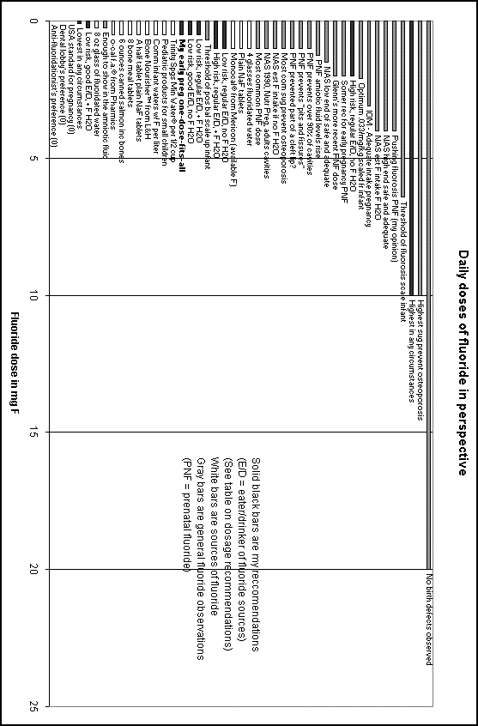

The table below probably has WAY more info about doses than you need. But if you're looking at the chart above with all the dose info, and you want to see what was meant by some cryptic remark like "No birth defects observed", you can get the details here.

|  |  |  |
| --- | --- | --- |
| Explanation of the chart "Daily doses of fluoride in perspective" | | |
| Dose in mg F | Short version shown on chart | Longer explanation, reference, etc. |
| 20 | No birth defects observed | Although the evidence is far from conclusive, it appears that humans can tolerate high doses of fluoride in early pregnancy without causing a noticeable increase in birth defects. There are places with ultra high fluoride naturally in the drinking water. Here pregnant women get a daily average fluoride intake of about 20 mg F, with no known problems with birth defects. (Teotia 1979, Fluoride12(2):58.)  (See even longer note below the table.) |
| 10 | Highest sug prevent osteoporosis | After preventing cavities, the second most popular (but relatively rare) use of fluoride is in the prevention of a bone disease, osteoporosis. There is not much to go on for evidence. The highest amount of fluoride I have seen suggested is 10 mg F per day, for people 8-25 years old, for the prevention of osteoporosis. (Dustin 1970, Fluoride in Medicine, TL Visher, ed, page 185. This suggestion was rejected on page 192. A more reasonable approach is about 1 mg F per day to prevent osteoporosis. See Osteoporosis, Mayes 1986, page 64.) |
| 10 | Highest in any circumstances | This is just my generalized highest recommendation. (For an early patent application I had to put a lid on it somewhere.) |
| 6.4 | Threshold of fluorosis scale infant | This is taking a fairly well known value from infant studies, and scaling it up to a 140-pound woman. (The infant dose that starts causing fluorosis, in about 20% of cases, is .1 mg / kg.) |
| 4 | Pushing fluorosis PNF (my opinion) | This is just my opinion of what dosage might start to cause fluorosis (white spots on teeth) if taken in pregnancy. (The permanent front teeth start forming at about month 7, and from that time forward I would make no sudden increases of greater than .5 mg per day.) |
| 4 | NAS high end safe and adequate | (see just below) |
| 4 | NAS est F intake  F H2O | The adult intake of fluoride considered to be "safe and adequate" by the National Academy of Sciences is from 1.5 to 4.0 mg F per day. This range is not reached by adults in non-fluoridated areas, where the estimate on fluoride intake is about 1.0 mg F per day. This range is said to be easily met in fluoridated areas, where the estimated intake is about 4.0 mg F. (1980 RDAs, page 156.) (This would be 16 glasses of water, though, so I think they're off.) |
| 3.1 | IOM - Adequate intake pregnancy | The first quasi-official recommendation specifically for pregnancy. The AI (adequate daily intake, which is the lower limit, for F from all sources) for pregnancy has been set at 3.1 mg F. (Institute of Medicine, Dietary Reference Intakes for Calcium, Phosphorus, Magnesium, Vitamin D, and Fluoride, 1997.) |
| 2.1 | Optimum  .033/mg/kg  scaled fr infant | This is another case of scaling up from infant values to 140 pounds. This dose is equivalent to what I say is best for infant teeth. |
| 2 | High risk, regular E/D, no F H2O | My recommendation for early pregnancy for HIGH-risk parents who are regular eaters / drinkers, and who do NOT have fluoridated water. (Please see dosage table). |
| 2 | Somer rec for early pregnancy PNF | A prominent expert on women's health and nutrition has recommended 2 mg F in the section of her book about early pregnancy. (Somer E. Nutrition for a healthy pregnancy. H. Holt & Co. 1995.) |
| 2 | Glenn's more recent PNF dose | Frances B. Glenn, DDS is by far and away the planet's best authority on prenatal fluoride. She published an excellent and entertaining book: How to have children with perfect teeth, Glenn FB 2000. |
| 1.5 | NAS low end of safe and adequate | (see NAS above at 4 mg) |
| 1.25 | PNF amniotic fluid levels rise | Lab work was reported that showed how much fluoride a mother has to take to have some leftovers appear in the amniotic fluid. (To get to the amniotic fluid fluoride has to pass from the mothers blood stream to the fetus, then pass through the fetus.) The smallest dose tested (.25 mg F) was enough to show in the amniotic fluid, roughly doubling the background levels. It took at least 1.25 mg to make the levels start to rise again (implying at least partial satisfaction of both bodies). The mothers were 3 to 4 months into pregnancy at the time of the test. (Brambilla 1994, Archives of Oral Biology 39(11):991.) |
| 1 | PNF prevents over 90% of cavities | (see most common PNF dose below) |
| 1 | PNF prevents "pits and fissures" | The closest thing to an absolute defect that is absolutely prevented by fluoride is from the prenatal fluoride studies of Glenn. There is a very common defect of molar teeth, called pits and fissures. The pits and fissures of the primary molars form at about the 5th month of pregnancy and show when these teeth erupt at about 2 years. Without extra fluoride in pregnancy most children (97%) have pits and fissures to some degree on at least one tooth. Of the total individual teeth, 28% have at least one very large pit. Prenatal fluoride makes a black and white change: only 2% of children have any sign of pits and fissures, and none of the individual teeth has a large pit. (Glenn 1984, ASDC Journal of Dentistry for Children 51:19.) It was trying to understand this paper by Glenn that got me started. You can see a crude version of the biology in the middle of this slide show on preterm births: [https://get.google.com/albumarchive/114685571384513740781/album/AF1Q](https://get.google.com/albumarchive/114685571384513740781/album/AF1QipO6WESBaQthSaRSH33JtI8GB9DyKfHc8ubRhlfV?source=pwa&authKey=COChjqad58aNTA)[ipO6WESBaQthSaRSH33JtI8GB9DyKfHc8ubRhlfV?source=pwa&authKey=COChjqad58aNTA](https://get.google.com/albumarchive/114685571384513740781/album/AF1QipO6WESBaQthSaRSH33JtI8GB9DyKfHc8ubRhlfV?source=pwa&authKey=COChjqad58aNTA) (sorry for the long URL, I can email it to you, [raygrogan@hotmail.com](mailto:raygrogan@hotmail.com) Once you get there, on some of the slides you will need to click the “circle i” in the top right to get all of the text.) |
| 1 | PNF prevented part of a cleft lip? | The most complicated science of human nutrition is total parenteral nutrition, or TPN. In TPN doctors are 100% responsible for nutrition because every thing a patient eats comes predigested, through a tube, straight into the blood stream. TPN is used in various conditions that do not allow the use of the patient's digestive tract.  There have been a few pregnancies reported during TPN. In at least a few of these pregnancies fluoride was began as soon as pregnancy was detected, including early pregnancy. In one of these the fluoride (1 mg) was began at about day 49. When the child of this pregnancy was born, it had what was thought to be partial cleft lip. That hit me like a ton of bricks, since the time the fluoride was started was right in the middle of the time cleft lips form. If an embryo with a cleft lip beginning is aborted on day 42, the cleft lip is visible microscopically. I think in this TPN case the cleft lip may have been forming from day 42 until the fluoride was started on day 49, and that is why the child ended up with a partial cleft lip instead of a full blown one. (Unfortunately this article does not say which side of day 49 the cleft is on. I have written but not gotten an answer.) (Mughal 1987, British Journal of Obstetrics and Gynaecology 94:44.) |
| 1 | Most com sug prevent osteoporosis | (see osteoporosis above at 10 mg) |
| 1 | NAS est F intake if no F H2O | (see NAS above at 4 mg) |
| 1 | NAS 1990, Nutr Preg, adults cavities | The RDA people seem to have finally given their tacit support of fluoride in pregnancy, and even to early pregnancy in the sense that they support fluoride for adults in general: "Adults may also derive some benefit [for preventing dental caries] from a fluoridated water supply or a 1-mg fluoride supplement per day...". (National Academy of Sciences 1990. Nutrition During Pregnancy. Page 311.) |
| 1 | Most common PNF dose | See a separate table on the half-dozen studies on prenatal fluoride (PNF). In a nutshell most prevented about 90% of tooth decay in the offspring. Most used 1 mg F, and started when the baby teeth start forming about month 3. PNF is now used by about 10% of doctors. The most well known study is Glenn 1982, American Journal of Obstetrics and Gynecology 143:560. |
| 1 | 4 glasses fluoridated water | A liter of fluoridated water is usually 1 ppm F, or 1 mg F. A liter contains roughly 4 8-ounce glasses of water. |
| 1 | Plain NaF tablets | Plain sodium fluoride tablets, 2.2 mg NaF, provide 1 mg F. A half tablet will provide .5 mg F. This form of fluoride would go well with a prenatal vitamin. This is by far the most commonly prescribed fluoride supplement, used for decades by millions of children and teenagers (and thousands of pregnant women). |
| 1 | Monocal® from Mericon (available F) | Monocal® from Mericon has 3 mg F actual, but it has enough calcium to make only about 1 mg of that available. There are a few ways you can get this down to .5 mg F: taking a half pill, or taking a whole one every other day, or taking a whole one with the biggest meal of the day. There is a similar product, Florical®. These are very high-quality calcium supplements, and sell for about $20 per 100 pills. These products are sold behind the counter, meaning you don't need a prescription, but you have to ask the pharmacist to order it, or order online. (I've tried all the F products, for me, just as an adult, and Monocal is my overall favorite.) |
| 1 | Low risk, regular E/D, no F H2O | My recommendation for early pregnancy for LOW-risk parents who are regular eaters / drinkers, and who do NOT have fluoridated water. (Please see dosage table). |
| 1 | High risk, regular E/D, + F H2O | My recommendation for early pregnancy for HIGH-risk parents who are regular eaters / drinkers, and who have fluoridated water. (Please see dosage table). |
| 0.7 | Threshold of pos bal scale up infant | This is yet another value from infant studies scaled up to 140 pounds. This is very roughly the dosage at which an infant starts gaining fluoride (versus peeing out more than comes in, using up reserves). The studies are pretty sparse in this area, and the actual value might be about half what I chose, ie, about .005 mg / kg versus my conservative .011. |
| 0.5 | Low risk, regular E/D, + F H2O | My recommendation for early pregnancy for LOW-risk parents who are regular eaters / drinkers, and who have fluoridated water. (Please see dosage table). |
| 0.5 | Low risk, good E/D, no F H2O | My recommendation for early pregnancy for LOW-risk parents who are good eaters / drinkers, and who do NOT have fluoridated water. (Please see dosage table). |
| 0.5 | My early preg one-dose-fits-all | I chose this dosage for people and doctors who don't want to fiddle with my dosage table. It is my opinion that .5 mg F is a fine dose to use for all modern women. This will not be too much for any woman who is living in normal circumstances. A dose of .5 mg F should be enough even for someone who was getting no other sources of fluoride. However, it is not too much trouble to get a daily dose that is a little more exact. Please see dosage table. |
| 0.5 | Trinity Spgs Min Water® per 1/2 cup | Trinity Springs Mineral Water® has 3.7 mg F per liter bottle. One half cup per day would be fine. |
| 0.5 | Pediatric products for small children | After infancy, pediatricians bump up the dose to .5 mg. Many pediatric products will give the dose of fluoride (.5 mg F) and other vitamins and minerals that pediatricians use for small children. |
| 0.5 - 0.7 | Comm infant waters w/ F per liter | There are commercial waters made just for babies. Most, but not all, have fluoride. (Beech-Nut® Spring Water with Fluoride and DS Services Nursery® Water are two brands.) These have half the fluoride of regular fluoridated water, and are perfect for use with powdered formula. |
| 0.5 | A half tablet plain NaF tablets | (see NaF above at 1 mg) |
| 0.5 | 8 bone meal tablets | Bone meal tablets, about 8 tablets a day, will provide the bioequivalent of a 1.1 mg NaF (.5 mg F) dose. |
| 0.5 | 6 ounces canned salmon inc bones | A good source of fluoride is ocean fish, in a can and including the bones. About 170 g (6 ounces) of canned salmon a day is a delicious choice, which also provides calcium and many other important nutrients for pregnancy. (Bioequivalent dose.) |
| 0.5 | o-cal f.a.® from Pharmics | At least 1 adult vitamin-mineral product contains .5 mg F. It is o-cal f.a.® from Pharmics 1 800 456-4138. It also supplies the common prenatal nutrients, but to get the trace nutrients, you would also need a trace element mix such as Essential Minerals® from VRP 1 800 877-2447. One tablet of this (not the 3 shown on the label) will give a reasonable dose. (Another trace element mix is Right Choice® from Body Wise®, Carlsbad CA. 1 caplet. The big chain GNC® 1 877 716 6862 was one of the first businesses to promote folic acid supplements in early pregnancy, and they have at least one trace nutrient product, I think called Trace Element Mix. ) |
| 0.25 | Enough to show in the amniotic fluid | (see amniotic fluid above at 1.25 mg) |
| 0.25 | 8 oz glass of fluoridated water | A glass of water is roughly one fourth of a liter, and a liter of fluoridated water is roughly 1 mg F. So a glass of water is about .25 mg F. |
| 0.25 | Low risk, good E/D, + F H2O | My recommendation for early pregnancy for LOW-risk parents who are good eaters / drinkers, and who have fluoridated water. (Please see dosage table). |
| 0.1 | Lowest in any circumstances | This is just my generalized lowest recommendation. (For my former patent application I had to put a bottom on it somewhere.) |
| 0 | USA standard for pregnancy (0) | There is a reason why it is highly unlikely a pregnant woman would get prenatal fluoride unless she went out of her way to ask for it. In the United States it is legal to sell fluoride for anyone except pregnant women, the very people who need it the most. You can sell fluoride for babies, adults, teenagers, lactating moms, grandmothers, women in general, but you can not say a word about pregnancy on the label of any product that contains any fluoride. It is specifically illegal to put fluoride in products like prenatal vitamins, thanks to the dental lobby, way back in 1966. To this day they refuse to allow it. (21 CFR 310.502) (They don't need my criticism. What we need is a system where dentists get paid not just for fixing teeth, but also bonuses for helping parents have children with no cavities or crooked teeth. Similarly, doctors earning retirement by helping raise healthy kids. This will be a very tricky app to design. Try doing it in your own family trust.) |
| 0 | Dental lobby's preference (0) | The dental lobby usually sounds pro-fluoride, but they fight like tigers to keep supplementation at zero for the first year or so teeth are developing. If you would like to see some of their craftsmanship, see Leverett DH. Clinical trial of the effect of prenatal fluoride supplements in preventing dental caries. NIH-NIDR-NO1-DE-32441; April 1992. Available free of charge from: Mr. Wayne Little / Public Information and Reports Section / Room 2C35 Building 31 / National Institute of Dental Research / 9000 Rockville Pike / Bethesda, MD 20892 / (301) 496-4261. (Or see summary in Caries Research 1997; 31:174-179.) In this huge clinical trial, it was found that something like 90% of children were cavity-free if they started fluoride at either of two times, pregnancy or birth. However, the conclusion was not that EITHER starting time is fine. It was that NEITHER was OK. A few years later the same author is pushing waiting until age 3 years to begin supplements. Assessment of dental fluorosis in relation to the dosage of dietary fluoride supplements used. NIH-NIDR-NO1-DE-22593; August 1994. Prenatal fluoride remains illegal, and they managed to get pediatric recommendations to drop fluoride for the first 6 months of infancy. (Even given this crap from their leaders, your own family dentist may be your best source.) |
| 0 | Anti-fluoridationist's preference (0) | Anti-fluoridationists generally imply that fluoride is toxic at all times and at all doses. However, if you ask them for specific recommendations for pregnancy and infancy they sound eerily like the dental lobby. |

More detailed notes.

From 20 mg per day, "No birth defects observed"

(References at end.) People who live in high fluoride areas have fluoride intakes that are staggeringly high. For example, Teotia shows a group of pregnant women with an average daily intake of 21 mg F, with the range going up to about 37 mg. (Equally staggering is the apparent use of fluoride by the growing fetus and/or the remodeling mother. In Teotia's charts it looks to me like these two uses clear about a fourth of the fluoride by the 6th month and over half by the 9th. There is no noticeable fluoride use in early pregnancy.)

Mason's review of births in these high fluoride areas did not reveal any problems as far as birth defects go. The extent of the review is simply that "birth defects have not been reported among children born in these areas" that have naturally fluoridated water that is 10-20 times higher than optimum. I have never seen an actual survey of birth defects in these high F areas.

Animal experiments do not indicate that fluoride is teratogenic at any dose. A recent FDA study in rats used doses up to 11.4 mg F/kg (25.1 mg as NaF, in drinking water) and found no developmental defects (see Collins).

Although not a birth defects study per se, the best example is in dairy cattle fed doses of fluoride that went from normal to fluorotic (see Newell). Essentially, all of the normal signs of fluorosis (teeth first, then hair and bone problems) appeared, but the signs of reproductive health (fertility, % of live births, and gestation time) all went slightly up and seemed to peak just before the highest dose.

It is noteworthy that these dairy cows, in their normal feeding pattern (whole grains and rough vegetable matter) and with low F well water (.1 to .2 ppm F), were getting a daily fluoride intake of .15 to .3 mg/kg. That works out to about 10 - 20 mg F per day for a 140 lb woman (but this should be divided by about 3 for bioavailability, making the "NaF" dose 3 - 6 mg F/day). The highest dose tested was 2.5 mg/kg, mostly NaF, or over 150 mg F for a 140 lb woman.

References:

Collins TF, Sprando RL, Shackelford ME, Black TN, Ames MJ, Welsh JJ, Balmaer MF, Olejnik N, Ruggles DI. Developmental toxicity of sodium fluoride in rats. Food Chem Toxic 1995; 33(11):951.

Mason JO (Committee to coordinate environmental health and related programs). Review of fluoride benefits and risks. US Public Health Service 1991. Teratologic and developmental effects are reviewed on pages 67-9.

Newell GW, Schmidt HJ. The effects of feeding fluorine, as sodium fluoride, to dairy cattle - a six-year study. Am J Vet Res 1958; 19: 363-76.

Teotia M, Teotia SPS, Singh RK. Metabolism of fluoride in pregnant women residing in endemic fluorosis areas. Fluoride 1979; 12(2):58.

|  |  |  |
| --- | --- | --- |
| Dosage table  Fluoride doses (mg F, NaF equivalent) for early pregnancy | | |
|  | Fluoridated water | Non-fluoridated water |
| Good eater and drinker (= eater of good sources of fluoride and drinker of tap water) | 0.25 | 0.5 |
| Regular eater and drinker | 0.5 | 1.0** |
| High risk* | 1.0** | 2.0** |

(* High risk is defined here as parents who already have 1 child with both birth defect and some sign of fluoride deficiency [enamel defects, pits and fissures, caries, or malocclusion], or parents who had birth defects as children and are now having children of their own, or parents-to-be being treated for infertility, or HIV infected mothers-to-be. For details and citations see my site on birth defects.)

(** There are no known risks with any of the doses in this table, and the following cautions may be ignored. However, doses of higher than .5 mg are probably more than a natural meal's intake. For extra care, particularly between day 17 and 57 of pregnancy, intakes of over .5 mg could be taken in separate doses. Care could also be taken to not cause a sudden increase in fluoride intake during early pregnancy. I suggest increasing the dose by .5 mg a day, or starting before pregnancy.)

Some formulations of fluoride (for example, with lots of calcium) have a high mg F, but actually deliver to the bloodstream about a third as much fluoride as an equivalent amount of sodium fluoride.

Ray 12-18-17

raygrogan@hotmail.com