A Infant fluoride dosing by body weight - OptiDose website in Word – DBW URL 12-13-17

Infant fluoride and the OptiDose® dropper - by Ray Grogan

Welcome  This site is about teeth. You, as a parent or doctor helping parents, have a big influence on how teeth grow. The most important thing that you have control over is how much fluoride the child gets as his or her teeth are growing.  This picture shows a new set of permanent teeth just coming in. This is pretty close to what I consider ideal and what I will try to give you a recipe for.  I am just a regular parent who got very interested in fluoride. Most of the ideas on this site are from the people I consider the best in the field: "The doctors Glenn" are a husband and wife team. Frances B. Glenn, DDS (RIP) and W. Darby Glenn, MD are experts in prenatal fluoride. The expert in childhood fluoride is a pediatrician, Tom C. Peebles, MD (RIP). | 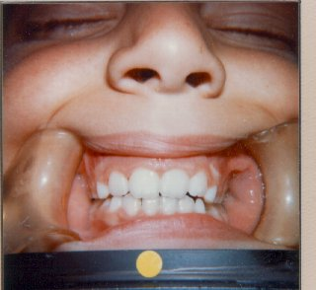

Basics of too much and too little

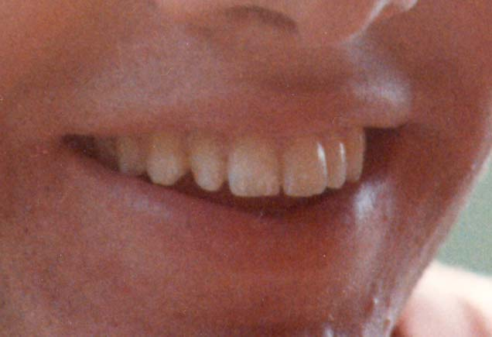

The most common effect of too much fluoride is white spots on the front teeth. This picture is of a very mild case, which is the most common (seems like about a fourth of parents have these).

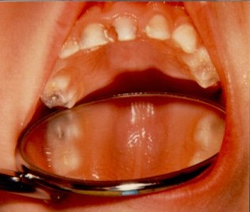

The most common effect of too little fluoride is cavities. This is a pretty bad case so that the decay is visible. (You and I can't even see most cavities before they are caught and fixed.) Many modern children still get at least a few cavities. As early as age 5 years about half already have their first.

Growth  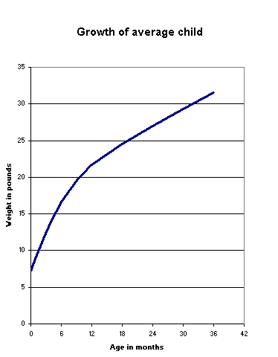 | Your baby will grow. Most double their birth weight in the first six months. (Your pediatrician will give you a much more detailed growth chart for your baby. This one just shows the average.) The tricky part for fluoride is keeping the dose correct even though your baby's weight is changing so much.

OptiDose®  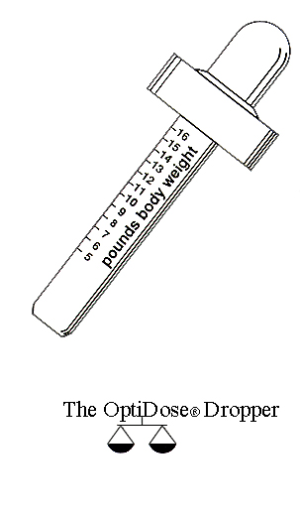 | You can get a new type of medicine dropper through your pediatrician. It has a body weight scale right on it.

For pediatricians  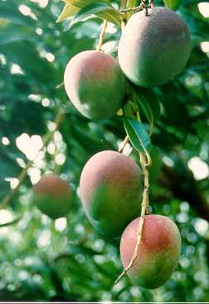 | The rest of this site is for pediatricians, but you parents are welcome to follow along. The main goal of this series is to show you the way that fluoride can be used to create good-looking teeth. (This is slightly different from the historic reason to give children fluoride, preventing cavities. We want to do that, too, of course.) I would like to convince you that adding fluoride to childrens' teeth is like adding white pigment. You want the whiteness, but you want it to be blended in, not just slapped on.  In order to blend in the white pigment, there are four key elements. First, start as early as you can to avoid a change in the middle of the tooth. Second, be consistent with the doses. Third, ease into any dosage changes. And fourth, err on the side of lower doses rather than higher doses.  The photo is of a mango variety we love to grow in Hawaii. The Haden mango starts out as a green fruit with a purple "blush". As the fruit ripens (the bottom one is the ripest, the top one is the least ripe) the green part turns yellow. The blush then starts looking red, even though its pigment doesn't actually change.

Watch where you’re going  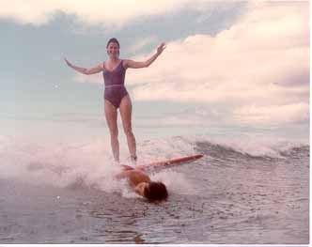 | Please be careful. You can be having a great time with fluoride and be doing things to your patients' teeth that you won't see until the child is about 10 years old.  Here are two old friends learning to surf. Cheney is running over Kevin. He lived.

Zebra teeth  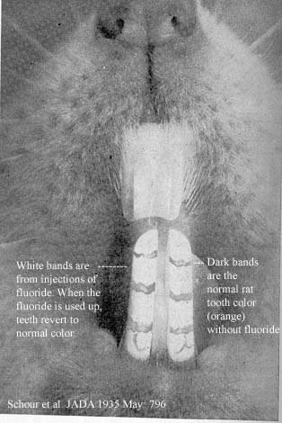 | This is the most dramatic picture I have to show you the "white pigment" effect of fluoride. Human teeth are not affected nearly as much as these rat teeth, but the general idea is true.  Here are a few details. There are 3 reasons the rat teeth show the effect so much. First, rat teeth are naturally darker (an orange color), so the white stands out in contrast. Second, the fluoride was given by injection, so there is an immediate jump in the blood concentration of fluoride. If the rats drink or eat the fluoride the effect is more mixed. Third, these rat teeth grow a little differently than other teeth. Most teeth grow in layers, and then erupt all at once. Instead, these rat teeth erupt constantly (and are worn down constantly), so are grown in daily increments on the end and pushed on up. That way each new bit of growth (and its coloration) is distinct, rather than lost in a layer as on our human teeth.  (In rats' teeth iron and fluoride take the same spot in the matrix, making the teeth orange - with iron, or white - with fluoride. From "Fluorine and Dental Health", by H. Trendley Dean, a 1942 book from when this was all new. Iron is critical for crosslinking in collagen. Some human families – like mine – have a tendency toward teeth with an orange tinge.)

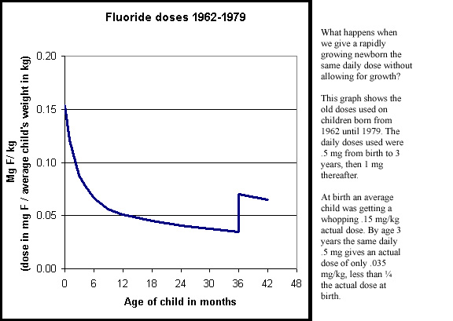

It was Dr. Tom Peebles (RIP, first chairman of our company, Prophy Research Corp) who was the first to notice all was not quite well with this dosage schedule. He noticed many of his patients had white spots on their front teeth.

(These reports are to this day the best reading in how to use fluoride supplements: Arch Oral Biol 1974; 19:321 and 1978; 23:111. Doses were changed in 1979. My focus is on the white spots, because I think today we can prevent them. However, the cavity prevention of these doses was tremendous: 80%. This was far more important than a few little white spots.)

These results, and others, helped establish a "threshold of fluorosis" at 0.10 mg F / kg. If teeth are growing, and the dosage goes over this threshold, white spots will often form.

The next illustration is not critical to understanding fluoride doses, and you can skip on past if you like. Some of you may enjoy the detail.

How the doses hit the teeth

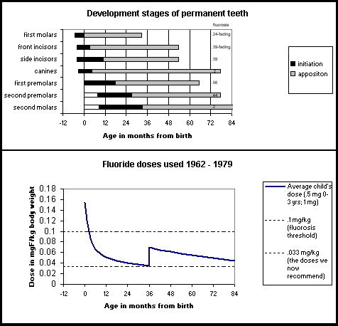

Development stages of teeth versus fluorosis

The general idea here is to look at what the teeth are doing (top chart) as the fluoride is taken (bottom chart). Then look at how severe the fluorosis is (the little numbers added to along the right side of the top chart).

Let's use the top tooth as an example. At birth (zero on the age scale) the first molar is starting the stage called apposition (the lighter part of the bar). And way off to the right you can (barely) see the fluorosis score, ".24 fading". The higher this score, the more fluorosis there was on that tooth type. Note that the bottom chart is lined up, time wise, with the top chart.

Now, scanning all the effects on all the tooth types, I can draw a generality. What it says to me is that the most sensitive stage of tooth development is probably the "initiation" stage. Here is how I come up with this.

If the high doses at birth hit near the end of the initiation stage, as in the first molars, the fluorosis is very mild and tends to fade. If the high doses hit right at the beginning of initiation, as in the first premolars, the fluorosis is at its most severe. If the high doses hit well before initiation, and then are lower when initiation starts, as in the second molars, the fluorosis is also very mild. (The canines with their mild fluorosis are the only teeth that do not fit the pattern.)

Here is a brief summary of the stages of tooth growth. The initiation stage is the beginning of the growth of a tooth. For our purpose we can think of initiation as beginning a cellular stage of growth, when cells form the outline of the eventual shape of the tooth.

The next stage of growth is apposition. This is the "matrix" stage, when the cells above start secreting matrix, which is sort of like cartilage. The matrix makes a complete tooth. In the next stage, calcification (not shown on the chart), the matrix tooth is mostly dissolved and replaced by calcium and phosphorus, which makes the tooth more bone like.

It does appear that the time near birth, when the main "smile teeth" are in the critical initiation stage, is the main time to be concerned with fluoride overdoses.

Physical effects of fluoride

Most of this site is about how fluoride prevents cavities and makes teeth whiter (including white spots). You may want to look quickly at the other observable physical effects of fluoride on teeth.

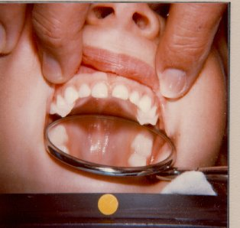

Here is one of Dr. Glenn's lucky patients. You can see the whiteness of the primary teeth from prenatal fluoride. The other effects you can see if you look closer are the smooth molars and glossy enamel. Let's go in for close-ups.

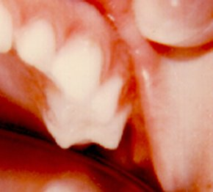

The smooth molars remind me of the time I took my first child to his first dental appointment at about age 3. I had tried prenatal fluoride, but didn't know much. The dentist's first words were, "Hmm, no pits and fissures", which didn't mean anything to me at the time.

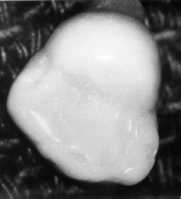

This is a close up of a very smooth molar. The total lack of pits and fissures is from prenatal fluoride.

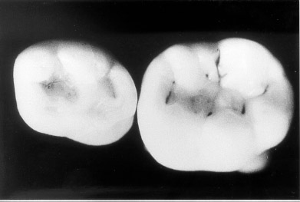

This is dramatic case of pits and fissures. Without prenatal fluoride, more than a fourth of molar teeth have a pit large enough to catch on an explorer.

(Glenn FB, Glenn WD, Duncan RC. Prenatal fluoride tablet supplementation and improved molar occlusal morphology: part V. ASDC Journal of Dentistry for Children 1984;51:19-23. A common developmental defect called pits and fissures is reduced from 28% to 0%.)

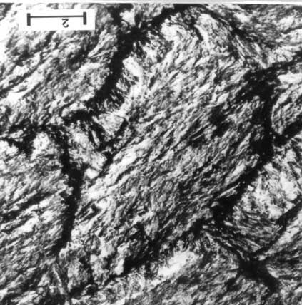

The other physical effect you can see with the naked eye is the smooth glossy enamel that looks something like the inside of a seashell. Above is the reason the enamel looks like that. This photo is from a scanning electron microscope. It shows the enamel surface of a tooth with prenatal fluoride. The size of the area is about the size of a cell.

It was hard for me to grasp the difference between this one and the one below (without fluoride) right away. The way it eventually made sense to me was thinking of it as the surface of concrete, and I had to use a pick to tear it apart. The one on the bottom has places I could put my pick to start prying pieces off.

(Photos from Dr. Glenn, from Dr. LeGeros I think.)

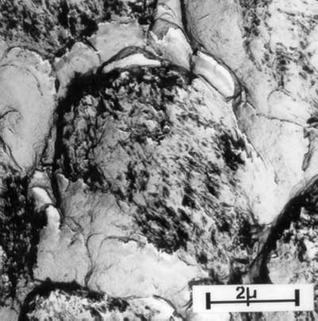

ECC

Early Childhood Caries (aka nursing caries, bottle rot, etc.)

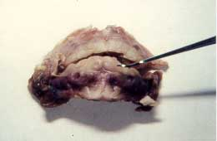

This is a fetal jaw near birth. Note the primary teeth are largely formed. We will focus on the top of the incisors, near the gum line. This part of the teeth forms just after birth.

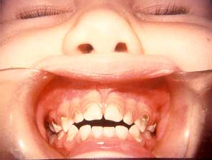
One type of decay we'd like to prevent is now called "Early Childhood Caries", or ECC. Those who have seen it know it develops very rapidly, and often destroys the child's front teeth within a few months.

The obvious time to prescribe fluoride to prevent ECC is during pregnancy. However, it may be possible to prevent ECC with fluoride starting at birth. (Above photos from the Drs. Glenn; the fetal jaw one was given to them by Dr. Leon Singer I think.)

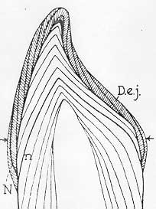

Above is a drawing of the neonatal line on a primary incisor. The neonatal line is formed in teeth where they are forming at the time of birth. (N shows the line in the enamel, n shows it in dentin). The area of the tooth that is hit with ECC is just on the birth side of the neonatal line. In other words, this critical enamel (arrows) forms just after birth. (Drawing from Schour I, Poncher HG. Rate of apposition of enamel and dentin, measured by the effect of acute fluorosis. American Journal of Diseases of Children 1937; 54:757-776.)

Below is a chart showing the quality of enamel formed at different times of a child's life. Note the particularly steep drop off between pregnancy (the best) and infancy (the worst). When you get to the cases below, note how the pregnancy enamel shows no sign of the attack, even as the infancy enamel crumbles.

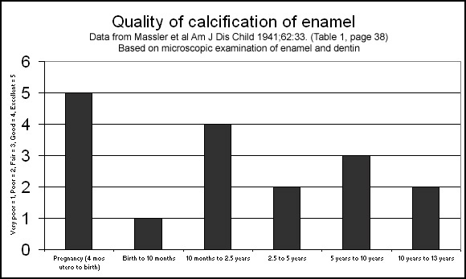

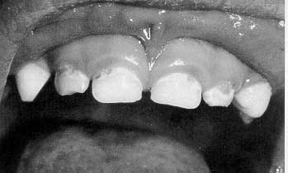

Above is a photo of the first visible signs of ECC. Below is a little later stage. (Photos from Milnes AR. Description and epidemiology of nursing caries. [Review]. Journal of Public Health Dentistry 1996; 56(1);:38-50. Excellent pictures of the progression of ECC.)

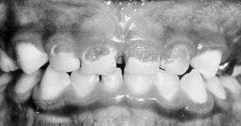

Comparing our recipe and the status quo

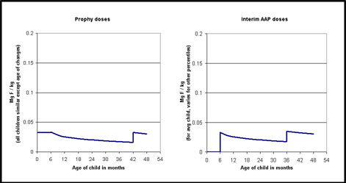

The chart is not very clear, but I think you can get the gist of it.

The main difference between the doses I recommend (chart on the left) and those of the AAP is the first 6 months. The AAP gives zero, where I give a dose by body weight of .033 mg F / kg. Later there is a little difference - I switch doses at a body weight and the AAP does it by age.

What is the significance of these differences? Well, that's hard. Let me first try another chart just to see the differences.

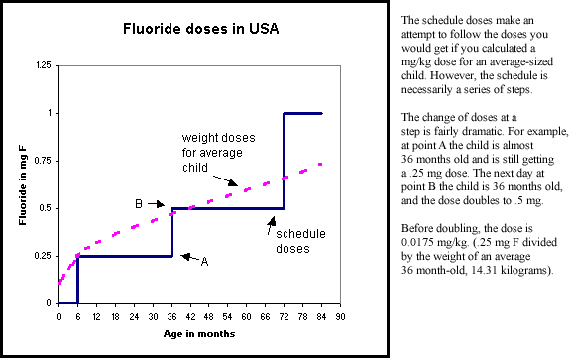

Now let's get back to the significance of the differences. We have not actually tested enough kids for long enough to see if there are any real differences. The answer I will give is based on theory and a few clinical trials of similar dose schedules in Europe. (I don't have that data with me, I'll add it in somewhere below.)

Cavities: The 6 month zone of no fluoride would theoretically cause a slight increase in cavities in the teeth that are forming during that first 6 months. The most interesting parts of the forming teeth are the tops of front baby teeth (see ECC page) and the chewing surfaces of the first permanent molars.

White spots: The jumps at each step, especially from zero to .25 mg at age 6 months, would theoretically cause the pigmentation to shift to a whiter color. These doses are pretty low, so I would not expect a big change, but it could be barely visible. The position of the change should be a little different than what we have seen from the old doses when the jump was at birth. It should shift about an eighth of an inch up from the leading edge of the incisors.

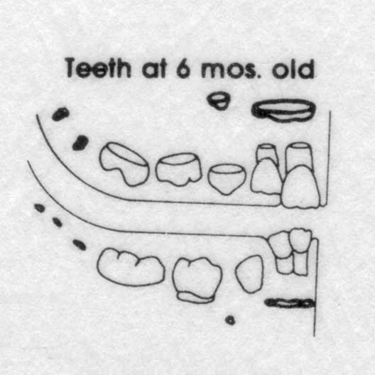

In the drawing above, of the teeth at age six months, you can picture where the action should be. The permanent teeth are shown in darker, bolder ink. On the permanent central incisors you can see the part that has just grown. With the old doses (high at birth), this is the part that has mild fluorosis. With the new doses, the mild fluorosis should be just above this part. In the back teeth you can see the chewing surfaces of the first permanent molars just forming. The baby teeth have grown quickly, and are just starting to erupt into the mouth.

(This drawing is adapted from Schour & Massler's classic text on how the teeth grow: Studies in tooth development: the growth pattern of human teeth. JADA 1940; 27:1778 (part 1) and 1918 (part 2).)

I still don't have the European data at hand, but let me wing it from memory. (It may be ages before I get around to fixing this.) I think there were three trials of the zero from birth to 6 months doses. (The rest of the schedules were fairly close to the AAP's , but not exactly like it.)

Two of these trials had only a control group for comparison, but were longer term. I think one found more cavities (than in different trials of the old .25 mg at birth), and did not look at fluorosis. The other one found no difference in cavities, even between the F and non-F groups, and lots more fluorosis. (This study was pretty whacko in grouping vast outcomes together.)

One of the trials was short - to about 5 years of age I think. It compared the zero-until-6-months group to a group that started at birth. It was a good trial but found no difference in caries. (Rats! But at age 5 most of the exposed teeth were formed in pregnancy, and we are not quite into enamel that formed with the various F levels.) And the kids weren't old enough to look for fluorosis yet.

So I have to admit that at this point there is no proven* significance between starting at birth and at 6 months. So if you already think I am splitting hairs, don't read the next section on "zero start". I will argue for being even more persnickedy on doses.

* There is now some “proof”, noticed by Dr. Glenn. Cavities are increasing since the dental lobby got the pediatricians to take fluoride away from the youngest babies. The report is pretty long and hairy:

http://www.cdc.gov/nchs/data/series/sr_11/sr11_248.pdf

From its conclusions: [dental health for almost everybody has improved, for seniors, adults, adolescents …] “... However, the prevalence of dental caries in the primary dentition for youths aged 2–5 years increased from 1988–1994 to 1999–2004.” (Newborns born after May 1995 started getting no fluoride until age 6 mos.)

Zero start

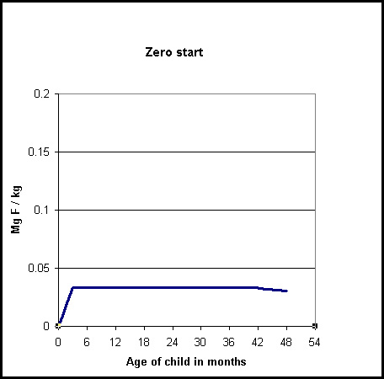

I do not expect to have the droppers made soon. But if I decide to waste some time and money, I'll make 2 new droppers with even lower doses than we now have (.033 mg F / kg). The new ones will be .011 and .022 mg / kg.

The idea will be to start gradually. It took me a few years to notice that when I start at birth at .033, it is still a jump up from zero. It is actually of the same magnitude as the AAP's first jump (see the middle chart on the comparison page).

My proposed solution is to give the pediatrician 3 droppers to work with for a newborn. I'll suggest from birth until a month old the lowest dose, .011, then up to .022 for a month, then regular doses (.033 mg F / kg). (Or super conservatives could stay with .011 until the AAP doses started.)

These doses are pretty low. I don't have my notes handy, but that .011 is about what it takes in balance studies to prevent a negative balance in fluoride. It is also about what the fetus should get in a well nourished pregnancy (at least 1 mg F a day, divided by mother's weight).

How many infants are low in fluoride?

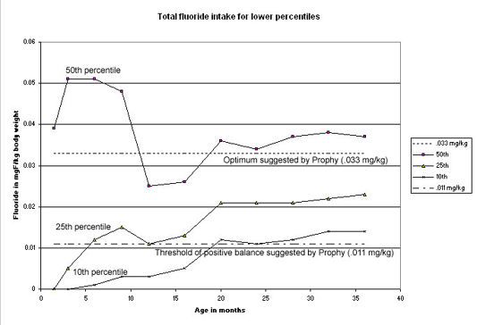

This study was based on the total intake of children in the real world. There was no intervention, just a look at what the kids got from toothpaste, supplements, and water. (The chart is on all sources.) The study was in Iowa on about 1300 normal Midwestern children. (Timing wise, this study ran from 1992-95, so mostly before the May 1995 new schedule from the AAP.*)

My take on this is that the average children (50th percentile line) are pretty close to what we would like to see.

(And this makes sense, as the recommendations most are following are based on the average child. The stated optimum intake from the AAP and most other sources is still .05 mg/kg. I think that dosage is fine, but a little dated as an optimum. I use .033 mg/kg and that is the line I put on the chart.)

However, look at the lower percentiles, the 10th and 25th. These children, especially in first year, are very, very low in fluoride. They are probably at or near a negative fluoride balance** much of the time.

Chart data: Levy, SM 2001, unpublished data from the Iowa Fluoride Study. steven-levy@uiowa.edu

See also Levy SM et al. Patterns of Fluoride Intake from Birth to 36 Months. J Pub Health Dent 2001. 61(2):70-7.

* Since the 1995 AAP schedule change, even more infants will be too low. The major change is dropping all fluoride supplements under age 6 months. At the time of the study, roughly 40% of the USA did not have fluoridated water, and if not infants were scheduled to get a .25 mg F supplement. That dose to a 5 kg (11 pound) infant is .05 mg/kg, which is where the 50th percentile is on the chart above, from about 3-10 months. Now many of these kids that were fine will drop into the negative fluoride balance zone.

** The line on the chart for the threshold of negative fluoride balance is just a guess. I'll get a chart up one day to show the guesswork. Basically you can say for sure that below an intake of about .005 mg/kg an infant will be losing fluoride. Then there is a lack of data until you get into the optimum zone. My guess is that if you can give an infant .011 mg/kg, odds are about 90% the infant will be gaining fluoride or at least staying even.

How many infants are high in fluoride?

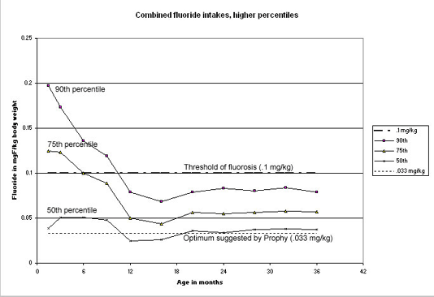

This is the same study. It was based on the total intake of children in the real world. There was no intervention, just a look at what the kids got from toothpaste, supplements, and water. (The chart is on all sources.) The study was in Iowa on about 1300 normal Midwestern children.

My take on this is once again that the average children (50th percentile line) are pretty close to what we would like to see. (The scale is much larger in this chart.)

(And once again it makes sense that the average children are OK, as the recommendations most are following are based on the average child. The total optimal intake is still .05 mg/kg, but that is a little dated. I use .033 mg/kg.)

However, look at the higher percentiles, the 90th and 75th. These children, especially in first year, are very, very high in fluoride. They are probably over or near the threshold of fluorosis much of the time.

(These children are not on "tracks" - at least some probably bounce around. For instance, if a child went from breast feeding to powdered formula in a fluoridated area, he or she could go from the bottom percentile to the top percentile overnight.)

(That high intake shown by the 90th percentile is not out of line with an average infant on powdered formula mixed with fluoridated water. For an easy example, a liter of formula is about 1 mg of F when the water is the usual 1 ppm F. For a 5 kg infant that is .2 mg/kg. As formula fades into solid food and juices, etc., the F intake drops way down.)

Chart data: Levy, SM 2001, unpublished data from the Iowa Fluoride Study. steven-levy@uiowa.edu

See also Levy SM et al. Patterns of Fluoride Intake from Birth to 36 Months. J Pub Health Dent 2001. 61(2):70-7.

Balance studies

In the balance study below Ekstrand used a special hospital ward to measure every bit of fluoride that went in or out of each baby's body. Let's look at a chart derived from his study.

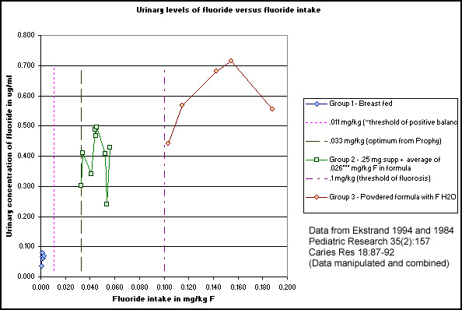

We can see which kids are in a state of negative fluoride balance from following the existing fluoride schedule. This shouldn't be hard to guess, it is the infants getting no fluoride. The group 1 infants are getting breast milk and nothing else.
In the new schedule, we will treat lots of children just like this group 1. There are no supplements given to ANY infants under age 6 months. So the only way they can get fluoride is to be using formula, and in such a way that mixes fluoridated water with it. All breast fed children will be in negative fluoride balance.

In the last schedule it was fewer children, the children living with fluoridated water, but getting none of it because they were breast fed.

We can also see which kids are over the threshold of fluorosis, also from following the schedule, and also not a surprise. These are the kids getting powdered formula made with fluoridated water, group 3 in the chart.

Group 2 is the closest to optimum, but they are a little high in my opinion. They are getting fluoride from 2 sources, either one of which would probably be fine alone. They are getting a .25 mg F supplement (these were 4 mo old infants, the average supplement dose was .041 mg/kg) AND fluoride in their formula of .026 mg/kg on average.

Minor fudge factor alert: I calculated the food intake by the difference in total F (avg .045) and supp F (avg .041), to get one feeding's worth, and multiplied that times 6 feedings per day. That's where my .026 mg/kg from F in food comes from. I may be off, but note that as a group these guys are a good bit higher than would be expected. That is, if you drew a line from group 1 to group 3, it would go under group 2 instead of through the center of it. The intake that is given and plotted is just from the 1 feeding, not from the rest of the day. But I think their urine shows the effect of their daily intake. Group 2 would fit the chart better if you scooted them over to the right by about .02, which is about the food F intake not given and plotted.

(I originally made this chart wondering if we could use urine levels to check the intake of kids. I'm satisfied that we can. One of these days I hope to do a little study in which the mom saves the pee from a few diapers. Then the pediatrician could have a lab check the F level, and, if it was out of the optimum range, make an adjustment in feeding or supplementation. Then we'd check the level again. I'll have to get a few new droppers made first, droppers that would allow even more precise dosing. Let me know if you'd like to participate when the time comes.)

Four ways to perfect doses

1. Fluoridated water and concentrated formula.

2. Commercial baby water and powdered formula.

3. OptiDose® dropper with supplements, for breast-fed and other ~zero fluoride methods of feeding.

4. A plain 1 ml dropper starting with zero at birth and gradually increasing to a full dropper by age 6 months. (Also for breast-fed and other ~zero fluoride methods of feeding.)

(See below for discussion, see dosing recommendations for specifics.)

Until now there has always been a tradeoff between getting too little fluoride (= tooth decay) and too much fluoride (= discolored teeth). In the last few decades many children have reached the goal of zero cavities, AND very nice-looking teeth. Many others came close - only a few cavities and/or a few small white spots.

It is amazing that we have done as well as we have. Some water has lots of fluoride, and some water has almost none. Some children are fed powdered formulas, which use lots of water, and others are breast fed and get none. Supplements were no better. They have come in one-dose-fits-all products, even though children vary greatly in size. (In the first products in 1962, the same doses were used all the way from birth to age 3 - when most kids grow about 500%.)

There is also the problem of just not knowing which dose is ideal. It takes about 10 years to see the result of how much fluoride a child is given. And none of the trials used a specific dose for the entire time a child's teeth are forming.

I would like to think that we now know what the perfect doses should be. We don't really, but a very good guess is about .033 mg F / kg. (There is more discussion on how that guess was made elsewhere.) So now it should be just a matter of working with various feeding methods and various levels of fluoride in the water. Here are 3 "easy" ways to get "perfect" doses of fluoride in infancy. (I'll also cover some trickier ones that many of your patients will not be able to follow.)

Doses in proportion to calories of food (various ways of mixing the fluoride in the formula).

It is common to get warnings about "fluoridated water plus powdered formula". This has been shown to give a dose that is over the threshold of fluorosis (generally accepted to be .1 mgF/kg). For example, Ekstrand showed a detailed balance study on 5 infants being fed powdered formula made with fluoridated water. For the youngest child (8 weeks) the intake was the highest at .19 mg F / kg. For the oldest child (17 weeks) the intake was the lowest at .10 mg F / kg. (Pediatric Research 1994 35(2):157). This amount of fluoride in this method of feeding has been shown to cause about 20% of the kids a mild grade of fluorosis. (Forsman B. Early supply of fluoride and enamel fluorosis. Scandinavian Journal of Dental Research 1977;85:22-30. One area in her study had water with 1.2 PPM F. If the children were fed with powdered formula before the age of 3 months, 36 out of 155 (23%) of them had mild fluorosis, versus 3 out of 41 (7%) if the formula started after 3 months (and versus 0% if no powdered formula). However, in these cases "this mild degree of fluorosis presented absolutely no aesthetic problem".)

While the above method - fluoridated water with powdered formula - may cause some minor spotting in very young children, there are two good methods that are theoretically perfect:

Fluoridated water is about two times too much for use with powdered formula. But fluoridated water with CONCENTRATED formula (uses half as much water) is perfect method #1. Fluoridated water is available out of the tap for about 60% of the country, and in 5-gal home delivery in most of the rest (see link below). Most stores carry small bottles of Dannon Fluoride to Go®. Some stores carry some Nestle brands of water with fluoride, like Deer Park® fluoridated water.

Next, if you're going to use powdered formula, there are commercial waters made just for baby. (NURSERY® Purified Water with added Fluoride and Beech-Nut® Bottled Water with added Fluoride are two national brands. In the midwest Hy-Vee has Mother's Choice Infant Water with fluoride.) These have about half the fluoride of regular fluoridated water, and are perfect for use with powdered formula (perfect method #2).

(Well, some have .5 ppm, which to me is perfect for powdered formula, and some have a wee bit lower or higher. Like NURSERY® is .7 ppm, which is to me is still 99% perfect. No one has tested all these permutations, so it is somewhat a guess anyway. There are also some other store brands of infant / baby water, with and without fluoride. I haven’t checked on all brands, and would appreciate any info.)

This method is great for us dads. All we need for a day's excursion with the kid is a bunch of diapers, a jug of NURSERY® water, and a few bottles with the powder already in the little bags. (Assuming you have the baby used to formula being room temperature.)

To me these waters are the best new thing for babies’ teeth to come along since Poly-Vi-Flor® back in 1962. The water companies cannot talk too much about their health benefits or safety features (there have not been clinical trials to back up any claims), but they are intuitively about the safest way to get fluoride to a small child. Since the “strongest” way they could be used is with powdered formula, and they are perfect for that, by definition they are safe for virtually any other infant use (regular drinking, juice mixing, cooking, etc.) which use far far less water / fluoride. About the only way you could overdose is using them with fluoride supplements. Even then you would be only at about the other slightly-too-much doses anyway (ie, about like powdered formula with fluoridated water, or the old 1962-74 doses). You could underdose, of course, but that happens with lots of babies anyway. A little is better than dead zero.

You can also have very competent parents mix their own fluoridated baby water. To make the half-strength type for powdered formula, just drop in two 1 mgF tablets (2.2 mg NaF) into a gallon of water. (Regular fluoridated water is one tab per quart or liter.) Or, if parents have fluoridated water they can mix it 50-50 with unfluoridated bottled water to make the half-strength baby water.

Common risks with food methods: Probably switches, like from concentrated formula to powdered. But since it takes a few months' worth of "mistakes" to show, this risk is probably minimal as long as the patient is seeing the pediatrician fairly often. Parents could also switch down, like from fluoridated water to plain water, or quit using formula. But once again the risk is minor - maybe a few extra cavities (this risk is not well-studied).

Certainly lots of infants are on both extremes all the time anyway. For example, in fluoridated areas lots of kids use powdered formula and lots are breast fed. The former we covered above. The same study showed that all of the breast fed ones were in negative fluoride balance. This can last 6 months or more. So our methods to more or less split the difference between common extremes is a reasonable option.

Proof of the method: Mixing fluoride with food lacks the clinical trials of supplements, but fluoridated water studies give it plenty of credence. The fact that at twice this intake fluorosis starts to show up certainly implies that we are in the right range. The only evidence I know of that says this method / dose would not be enough is from a balance study. Based on fluoride retained, giving small doses in the food may be only about one fourth of the same total dose in a daily supplement. I'll give you that reference and the relevant quote from it, but I still think this method and dose with food is enough or very close. (Ekstrand J, Ziegler EE, Nelson S E, Fomon S J. Absorption and retention of dietary and supplemental fluoride by infants. Advances in Dental Research Jul 1994; 8(2):175-80. In Regimen A, small amounts of fluoride were obtained in the diet in frequent doses throughout the day; in Regimen B, a fluoride supplement (.025 mg) was given each day with a feeding; Regimen C was similar to regimen B except that the fluoride supplement was given 1 hour before a feeding. ... the respective retentions were 12.5, 47.1, and 52.3% of intake.)

Doses in proportion to body weight (various ways of using fluoride supplements).

The interim AAP schedule (Pediatrics May 1995) does not give infants fluoride from birth to age 6 months. Historically, this age group originally got .5 mg (which was clearly too much) (Aasenden R, Peebles TC. Archives Oral Biology 1974; 19:321 and 1978; 23:111.). In 1979 the doses were lowered to .25 mg. I haven't seen any great data on this dose, but there are plenty of teenagers with very mild fluorosis. Now, by shifting to body weight doses, in effect we'll cut the dose in half again and keep it even. (Elsewhere we'll discuss step doses, etc.)

Using fluoride supplements is more or less the only choice for breast feeding and RTU (ready-to-use) formula feeding. This method can also be used with other types of formula feeding, as long as the formula is not mixed with fluoridated water.

The perfect method (#3) we suggest is to use the OptiDose® dropper with supplements. In this way the dose is exactly by body weight. We assume most parents will be able to use this one successfully. It is probably the easiest way to be fully compliant. Since most parents do not have a good scale, it is probably a good idea to give the parents the body weight written down as often as possible. The Rx instructions could also have the weight right on the label, such as: "Fill to 10 pounds body weight and give orally once per day".

A method that could do the same thing without our dropper is to just eyeball the doses. If you look at our dropper, you'll see a full dropper (1 ml) is 16 pounds, and a half full dropper is 8 pounds. From that you can construct fairly simple directions to go with a plain 1 ml dropper. The simplest would be to start at birth with a half full dropper and by age 6 months be up to a full dropper.

(For perfect method #4 you could even make a DIY “Zero start” with just a plain 1 ml dropper. Start at birth with about 1/10th of a dropper, and by age 6 months be up to a full dropper.)

In either method of dosing supplements (by weight or by eyeball), there is the issue of the infant rejecting the taste of the vitamins. The best method I know of is originally from our family pediatrician (Dr. Sylvia Pager, Honolulu). Here is the language I use in our instructions to the parents: "Most pediatricians say the best way to get an infant to take vitamins is to do it at the morning feeding when the baby is the hungriest. Get all set to feed, then give the vitamins first in one quick sploosh, then immediately start feeding. The reaction you want is "What was that? Ah, here we go with the good stuff."

Conclusion: It is not that big of a deal if you don't go out of your way to get the dose of fluoride just right. Most kids get some here and there and things work out well enough. The worst that will happen if you get too little is a few cavities, and the worst that will happen if you get too much is a few little white spots. If you get it perfect during the whole time teeth are forming, each and every tooth will be a gorgeous white color, have glossy enamel, and not a trace of decay. I think most parents would appreciate a chance to strive for this goal. However, I don't think we should act like it will be easy. The time teeth are forming spans from early in pregnancy until about the first grade. It is a long time to be a perfectionist.

Links

To a commercial baby water with fluoride:
http://www.nurserywater.com/

Ways to get fluoridated water delivered to your door:
http://water.com/ (Type in your zip code to see if you can get fluoridated water delivered in 5-gal cooler type jugs – mostly in big metro areas – about $7.50 per 5 gal. They also deliver the Nursery water in some areas.)

Best clinical trial on the old (.5 mg F at birth) doses – Aasenden and Peebles:
1974 (age 7-12 years, also includes some kids with just fluoridated water): https://www.dropbox.com/s/vtjqw7s1g1thcl1/Aasenden%20and%20Peebles%201974%20PDF.pdf?dl=0
1979 (age 12-17 years so all permanent teeth):
https://www.dropbox.com/s/hoj184fmhvf4nmf/Aasenden%20and%20Peebles%201979%20PDF.pdf?dl=0

Dose recs

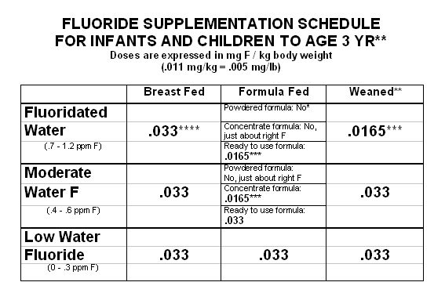

* Powdered formula plus fluoridated water supplies about 2 times the infants need. Even with no supplement there is a slight risk of mild fluorosis if under 3 mos. To get the fluoride intake perfect when using powdered formula, use a commercial baby water with about half-strength fluoride. (Example: Hinkley Springs Nursery® Water.) Overall this is one of the easiest and best methods of getting perfect fluoride.) Or mix fluoridated water 50-50 with bottled water, or alternate, etc.) (An easy mistake to make when using powdered formula is to assume the child spends all day at home. Check water fluoride levels at day care, etc.)

** Over age 3 years fluoride does not affect the appearance of any teeth that really show. For caries control keep the total fluoride intake from water and supplements at roughly .033 mgF/kg. An 8 oz glass of 1 ppm F water is about .25 mg F. Most children drink about 1-2 glasses per day. At about age 3 years (33 pounds) use .25 mg F in fluoridated areas, and .5 mg F in moderate and low fluoride areas.

*** We do not make a .0165 dropper yet (and this may end up a .011 dropper for other reasons).

**** Breast fed infants in fluoridated areas are tricky because you can set them up assuming no consumption of the water, and then the parent shifts to powdered formula. However, it takes about 2 months to make a mild spot big enough to see, and even then only in about 20% of the children. I think it is worth it to supplement as long as the parents come in often and you review the feeding methods each time.

e-mail to raygrogan@hotmail.com or jack-grogan@uiowa.edu

Ray Grogan
Prophy Research Corporation
2608 Court St.
Iowa City, IA 52245-4801 USA

(319) 321-5685 (cell)

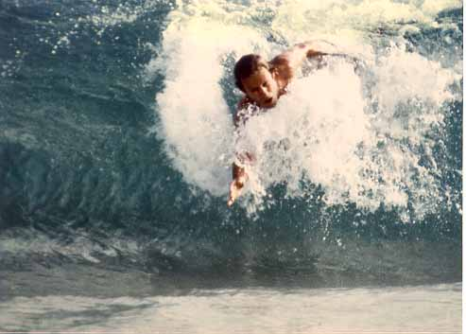
Occasionally I am in Hawaii catching a few waves. You can call me there at (808) 732-7476.

At either place (319) 321-5685.

Stockholder reports
2012 https://prophyresearch.wordpress.com/

See Dr. Glenn's book at Amazon.com

Thank you for visiting and good luck with your kids' teeth.

